**Harry Gwala District Municipality**

MFMA s71 & s52 (d) report for the period ending 30 June 2019.

Budget & Treasury Office

Table of Contents

1.1 Mayors Report 5

1.2 Executive Summary 6

**DELIBERATION** 7

1.3 Resolutions 10

1.4 Monthly Budget Statement Tables 10

2.1 Debtors Analysis 19

2.2 Creditors Analysis 24

2.3 Investment Portfolio Analysis 24

2.4 Allocation and Grant receipts and Expenditure 25

2.5 Councillor and Staff Benefits 26

2.6 Material Variances to the SDBIP 28

2.7 Municipal Manager’s Quality’s Certificate 40

**Glossary**

**Adjustments budget –** Prescribed in section 28 of the MFMA. The formal means by which a municipality may revise its annual budget during the year.

**AFS** – Annual Financial Statements

**Budget –** The financial plan of the Municipality.

**Capital expenditure -** Spending on assets such as infrastructure, land & buildings minor assets etc. Any capital expenditure must be reflected as an asset on the Municipality’s statement of financial position.

**DORA –** Division of Revenue Act. Annual legislation that shows the total allocations made by national to provincial and local government.

**Equitable share –** An unconditional grant paid to municipalities. It is predominantly

targeted towards funding the Indigent Policy.

**FMG** – Financial Management Grant.

**GRAP –** Generally Recognised Accounting Practice. The standard for municipal

accounting.

**IDP –** Integrated Development Plan. The main strategic planning document of the

Municipality.

**MBRR –** Local Government: Municipal Finance Management Act (56/2003): Municipal budget and reporting regulations.

**MFMA –** Local Government: Municipal Finance Management Act (56/2003). The principle legislation relating to municipal financial management.

**MIG** – Municipal Infrastructure Grant.

**MTREF –** Medium Term Revenue and Expenditure Framework (MTREF). The medium term financial plan, usually 3 years, based on a fixed first year and indicative further two years budget allocations. Also includes financial information of the previous and current year.

**Operating expenditure –** Spending on the day to day expenses of the Municipality such as salaries and wages, repairs and maintenance etc.

**SDBIP –** Service Delivery and Budget Implementation Plan (SDBIP). A detailed plan

comprising annual and quarterly performance information. Harry Gwala District Municipality MFMA s71 Monthly Report Page 5

**Strategic objectives –** The main priorities of the Municipality as set out in the IDP.

Budgeted spending must contribute towards the achievement of the strategic objectives.

**Vote –** one of the main segments into which a budget of a municipality is divided for the appropriation of money for the different departments or functional areas of

the municipality; and which specifies the total amount that is appropriated for the purposes of the department or functional area concerned. .

**YTD –** Year to date

**YoY –** Year on Year

**DBSA** – Development Bank of South Africa

1. **PART 1 – MONTHLY REPORT**

## **Mayors Report**

In accordance with Section 52(d) of the Municipal Finance Management Act, I submit a report to the council within 30 days after the end of the Fourth quarter of 2018/19, on the implementation of the budget and the financial state of affairs of the Harry Gwala District Municipality.

The submission of this report forms part of the general responsibilities of the Mayor of a Municipality, and is intended to inform and enable the council to fulfil its oversight responsibility.

**1.1.2 Implementation of the budget in accordance with the SDBIP**

A comprehensive report detailing the implementation for the fourth quarter ended 30 June 2019 will be tabled in a separate report to council.

**1.1.3 Financial problems or risks facing the municipality**

The cash flow position as at 30 June 2019 of the Municipality again shows a massive improvement when compared to the previous financial year. In the 2018/19 financial year, the municipality had Interim Finance Committee that monitored the expenditure and the municipality consider reducing non-essential expenditure by implementing cost containment measures as per Municipal Finance Management Act circular 82 to improve cash position and continue to implement the “belt-tightening” measures.

The municipality also has a revenue enhancement strategy that will assist the municipality to improve more in collection in order to reduce consumer debts as this will immensely contribute towards the municipality’s cash flow. Improving the debt collection will continue to rank high in the municipality’s priorities as we seek to improve financial sustainability.

## **1.2** **Executive Summary**

**Legislative Requirements**

In terms of the section 71 of the MFMA the accounting officer of a municipality must by no later than 10 working days after the end of each month submit to the Mayor of the municipality and the relevant provincial treasury a statement in the prescribed format on the state of the municipality’s budget reflecting the following particulars for that month and for the financial year up to the end of that month:

*(a)* Actual revenue, per revenue source;

*(b)* actual borrowings;

*(c)* actual expenditure, per vote;

*(d)* actual capital expenditure, per vote;

*(e)* the amount of any allocations received;

*(f)* actual expenditure on those allocations, excluding expenditure on—

(i) its share of the local government equitable share; and

(ii) allocations exempted by the annual Division of Revenue Act from compliance with this paragraph; and

*(g)* when necessary, an explanation of—

(i) any material variances from the municipality’s projected revenue by source, and from the municipality’s expenditure projections per vote;

(ii) any material variances from the service delivery and budget implementation plan; and

(iii) any remedial or corrective steps taken or to be taken to ensure that projected revenue and expenditure remain within the municipality’s

**DELIBERATION**

The discussion that follows, in terms of MFMA Section 71 & Section 52 (d) above, intends to inform the Council on the progress made thus far in terms of implementing the 2018/2019 budget for the period ending 30 June 2019.

The following table summarises the overall position on the capital and operating budgets.



**Budget summary**

The budget summary is intended to give an overall summary with regards to the implementation of the 2018/19 budget for the period ending 30 June 2019. Chart 1 presented below gives a summary of the budgeted Revenue, Operating as well as Capital expenditure and the movements for the month of June as well as the Year to Date movements (YTD).

Furthermore it compares the quarterly projections for service delivery targets and performance indicators contained in the SDBIP, against the actual outcomes of the municipality’s performance in service delivery for the 4th and last quarter of 2018/19.

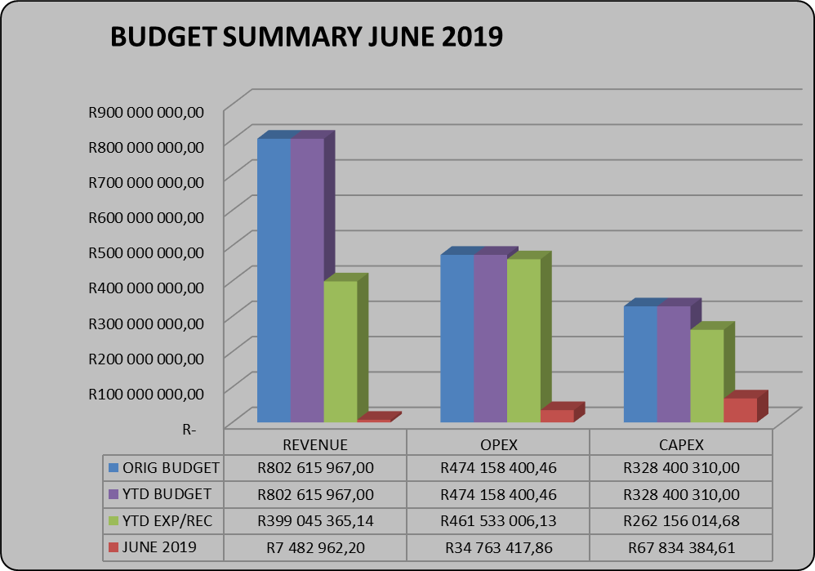

**Revenue by Source**

The Year-to-Date actual revenue is 85% when compared to the YTD budget.

**Borrowings**

The balance of borrowings amounts to R8, 6m at the end of June 2019 for ABSA loan. The next payment will be made at the end of December 2019 as per ABSA amortisation.

**Operating expenditure by vote & type**

Operating expenditure is at 97% when compared to YTD budget for the period ending June 2019.

**Capital expenditure**

The YTD expenditure on capital amounts to R262, 1million, or 80%, of a total budget of R328, 4million. Capital expenditure is mainly funded by means of national grants in the form of Municipal Infrastructure Grant.

**Cash flows**

The municipality started the year with a positive cashbook balance of R96, 6million. The closing cash and cash equivalents as at the end of June 2019 was R58, 3million. Refer to Supporting Table SC5 for more detail on the cash position.

**Allocations received (National & Provincial Grants)**

All DORA allocations for 2018/2019 financial year have been received as per payment schedule. Details of the grants have been presented in SC6.

**Spending on Grants**

Spending on grants amounted to R262, 1million or 80% for 2018/19 financial year.

## **Resolutions**

The following recommendations are linked to the responsibilities of the Mayor as contained in s54 of the MFMA.

It is recommended that the Mayor;

1. Notes the monthly budget statement and any other supporting documentation

2. Notes the quarterly report on the implementation of the budget in terms of s52 (d) of the MFMA

## **Monthly Budget Statement Tables**

**Monthly Budget Statements Summary**

Table C1 below provides a summary of the overall performance in the Municipality and is unpacked in the sections that follow.



**Financial Performance**

Table C2 provides the statement of financial performance by standard classification.



This table assess the revenue by department and then the expenditure for the period ending 30 June 2019. Revenue receipts in June has largely constituted of by service charges which is water and sanitation.

Expenditure by standard classification presents the expenditures by the departments. Waste Water Services has largest expenditure accounting for 10% of the YTD expenditure for the period ending 30 June 2019. This being largely attributable to the backlog demand of operations and maintenance of water schemes in the District.

Table C3 presents the same information as the table above, the difference being that it’s by Municipal vote.



**Statement of financial Performance**

This schedule provides information on the planned revenue and operational expenditures against the actual results for the period ending 30 June 2019.



**Capital Expenditure**

Table C5 below reports on the capital expenditures by departments (municipal vote) and also by standard classification. The bottom part of the schedule looks at the funding sources of the capital projects.



As alluded to above, the capital expenditure programme for the period ending 30 June was R262, 1m which represent 80% of capital expenditure and thus shows the reduction on expenditures reflected on National grant funding.

The chart below presents a high level analysis of YTD capital expenditure budget against the YTD actual expenditure.

**Chart 1: 2018/2019 FOURTH QUARTER CAPEX**

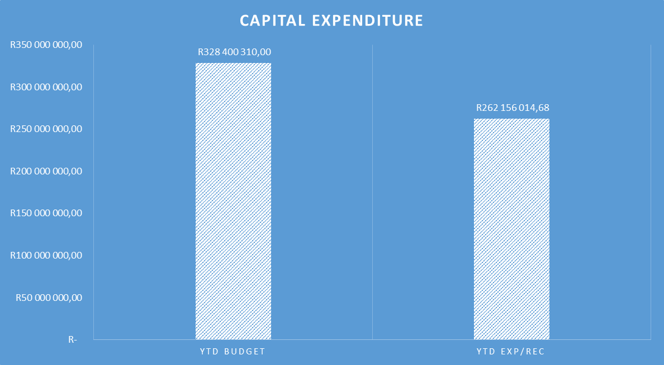

As at 30 June 2019, the year to date actual expenditure was R262, 1million against a YTD budget of R328, 4million. In monetary terms, these figures represent 80% per cent performance against the capital development programme as at 30 June 2019.

**Table C6 displays the financial position of the municipality as at 30 June 2019.**



Table C7 below display the Cash Flow Statement for the period ending 30 June 2019.



**PART 2 – SUPPORTING DOCUMENTATION**

## **Debtors Analysis**

The table presented below summarises the Debtors Age Analysis as at 30 June 2019.

**Table 2.1.1: Debtors Age Analysis by Income Source**



The municipal consumer debt is currently increasing citing rigorous actions to ensure that this trend is prevented from continuing as it has a direct negative impact on municipal cash flows.

**Debtors Age Analysis By Customer Category**

Table 2.1.2 analyses consumer debt by Category. A further analysis in the form of a chart is provided below.

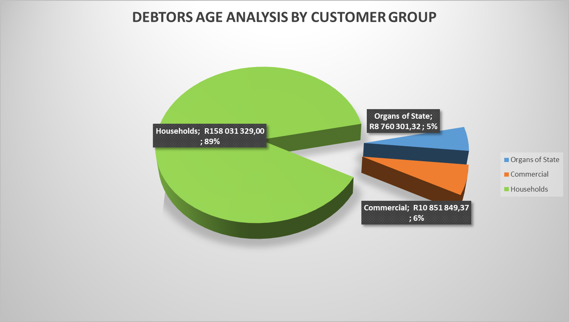

**Chart 2: Debtors Age Analysis by Customer Group**

The information presented in the chart above ranks total debt owed to the municipality from highest to the lowest,

* Households: 89%
* Government 5%
* Business 6%

The chart above shows that for each debtor type the amounts owing to the municipality have increased on a year to year basis.

**Revenue receipts per Area**

|  |  |  |
| --- | --- | --- |
| **AREA** | **AMOUNT** |  |
| **JUNE 2019** | **MAY 2019** |
| Unallocated receipts | R 869 474,41 | 20% | 24% |
| Bhongweni | R 19 001,53 | 0% | 1% |
| Shayamoya | R 1 310,00 | 0% | 0% |
| Kokstad | R 2 548 947,15 | 60% | 47% |
| Ixopo | R 278 188,81 | 7% | 15% |
| NDZ | R 396 881,66 | 9% | 8% |
| Umzimkulu | R 134 146,85 | 3% | 6% |
| Fairview | R 163,00 | 0% | 0% |
| TOTAL RECEIPTS INCL VAT | **R 4 248 113,41** | 100% | 100% |

The table above presents the cash receipts from consumer debtors in each of the detailed areas as well as the comparative receipts for the previous month. The total cash collected for June 2019 is R4, 2million.

**CHART 3: BILLING VS COLLECTION (COMPARISON BETWEEN MAY AND JUNE 2019)**

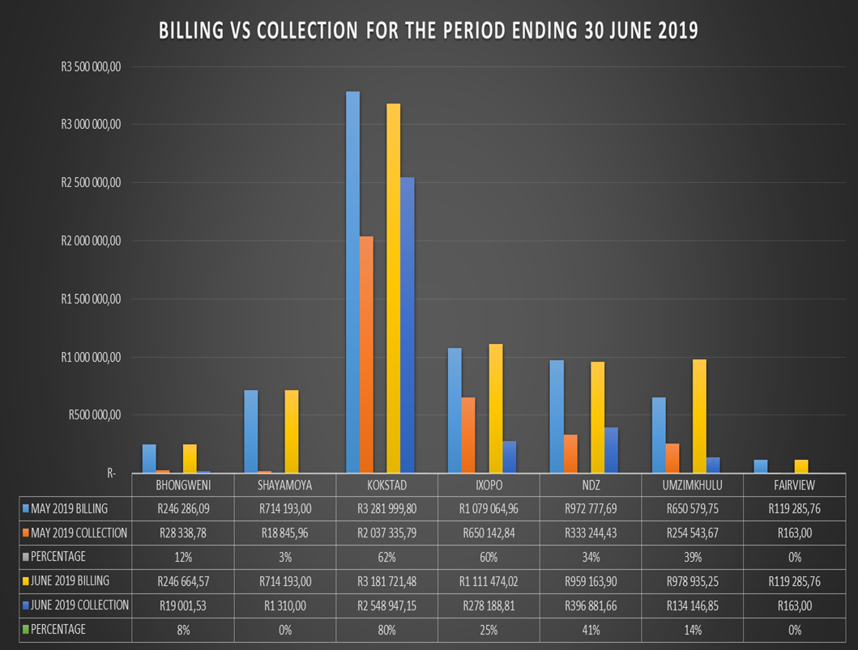

**CHART 4: BILLING VS COLLECTION TREND FOR MAY AND JUNE 2019**

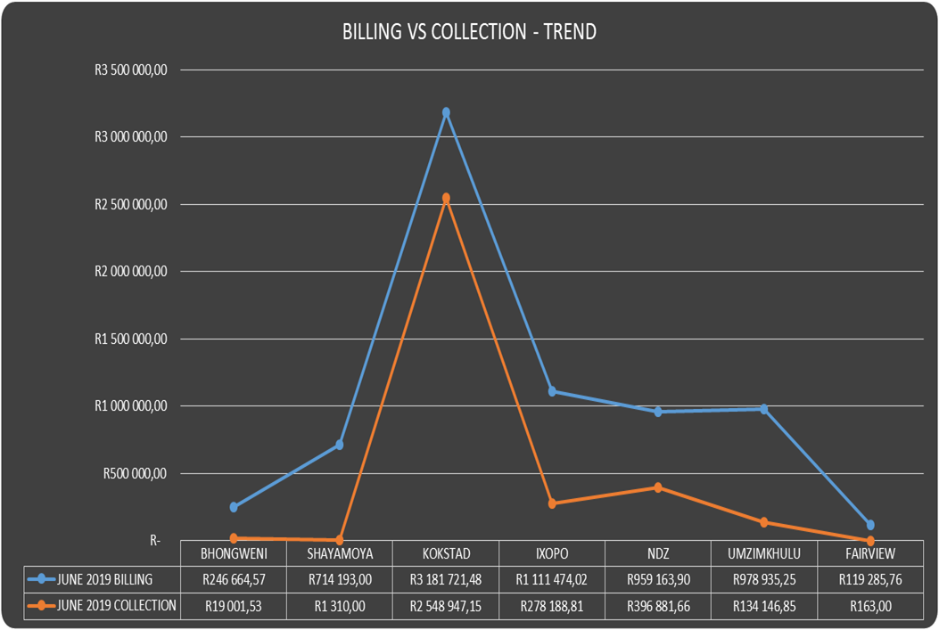

## **Creditors Analysis**

Table SC presents the aged creditors as at 30 June 2019



## **Investment Portfolio Analysis**

The following information presents the cash at bank and short term investments balances broken down per investment type as at 30 June 2019.

**Cash and Bank Balances (Investments)**



## **Allocation and Grant receipts and Expenditure**

Table SC 6 displays information relating to grant receipts.



It is clear from the chart above that the bulk of the grants received by the municipality are from the National Treasury.

**Table SC7 track the expenditure on Conditional grant funding.**



## **Councillor and Staff Benefits**

Table SC8 presents the expenditure of councillor and staff benefits at 30 June 2019.



## **Material Variances to the SDBIP**

The following section analyses material variances between the actual targets as at 30 June 2019 and the budget for the same period. This report analyses each major component under following headings;

* Revenue by Source
* Operational Expenditure by Type, and
* Capital Expenditure
* Financial Position
* Cash Flows

**REVENUE**

The chart displays a comparison between the 2018/2019 financial year revenue budget and the performance against this budget as depicted in the form of Year to date (YTD) Actual figures. It should be emphasised that the information presented relates to “performance” rather that “cash movements” in terms of the revenue items listed below. This accounting principle relating to municipal performance is best illustrated in the analysis that follows.

**Chart 3: Revenue Analysis**

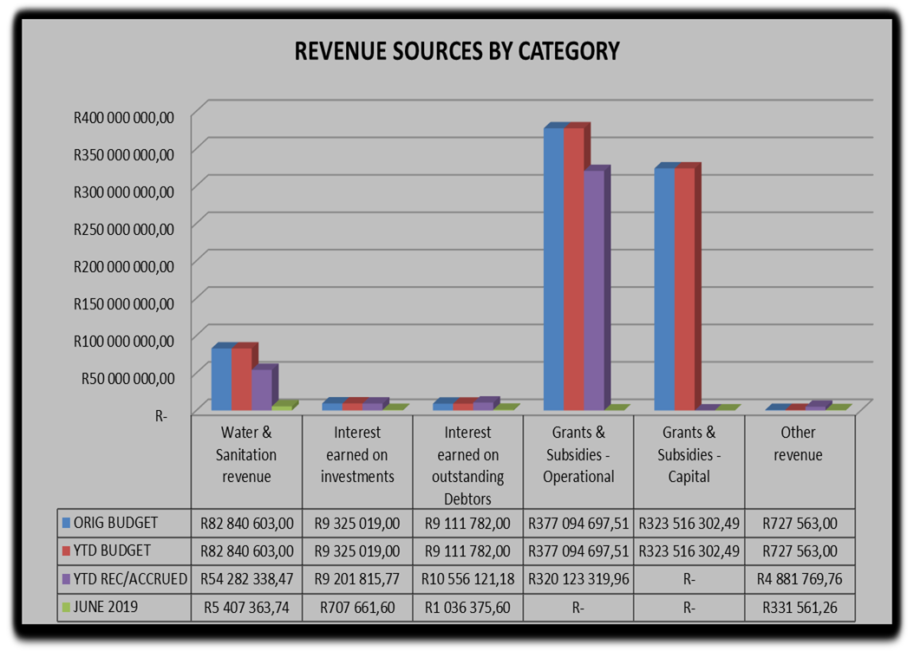

**Water & Sanitation Charges**

The year to date **actual** water & sanitation charges **(billing)** as at 30 June 2019 was R54, 2million against a year to date **budget** of R82, 8million 66%. However, this percentage measures the municipal performance in terms of the ability to bill consumers that are receiving services from the municipality and **is not** a measure of the ability to collect outstanding consumer accounts.

**Interest Earned on External Investments**

The year to date actual interest earned on external investments for the period ended June 2019 is R9, 2m against a year to date budget of R9, 3m.

**Transfers Recognised - Operational**

The operational grants revenue of R320, 1million against a budget of R37million is largely attributable to the YTD equitable share.

**Transfers Recognised – Capital**

The expenditure trends on grant funded expenditure had resulted in a positive way as expected against the set targets. The actual R262, 1million (against a YTD budget of R328 4million) represent the conditions met in capital expenditures against the conditional grant allocation received.

**Other Revenue**

The YTD performance of other revenue is R4, 8m against YTD budget of R727 563 of original budget.

**OPERATIONAL EXPENDITURE**

The chart below presents the YTD operational expenditure movements against the YTD budgets. An analysis of each expenditure line item category is discussed below.

**Chart 4: 2018/19 financial year Operating expenditure**

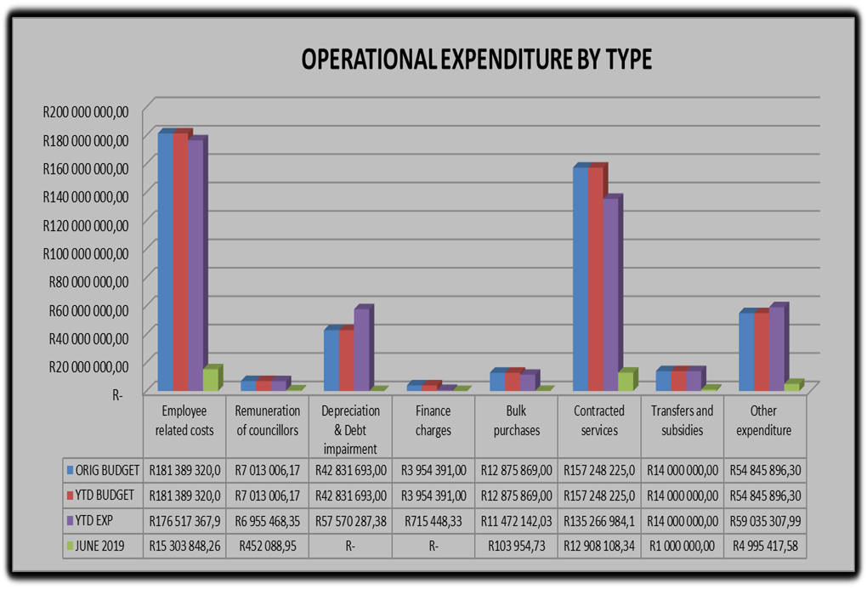

**Employee Related Costs**

The Original budget for employee related costs is R181, 2million and the year to date budget is R181, 3m against a YTD actual of R176, 5million which is 97% of the planned budget.

**Remuneration of Councillors**

The remuneration of councillor’s year to date expenditure is at R 6, 9million against a YTD budget of R7million representing 99% of the year to date budget.

**Finance Charges**

As at 30 June 2019, the year to date expenditure for finance charges is at R2, 6m against a YTD budget of R3, 9million representing 66% of the year to date budget.

**Bulk Purchases**

The original budget for Bulk Water purchases is R12, 8million and the year to date expenditure is at R 11, 4million against a year to date budget of R12, 8million. The expenditure for bulk water purchases is at 89% of the planned budget as at 30 June 2019.

**Other Expenditure**

The YTD budget for other expenditure was at R54, 8milllion against a YTD expenditure of R 59million for the month of June 2019 representing 108 per cent of the year to date budget.

**Performance assessment**

The section that follows takes a look at actual performance achieved against planned targets

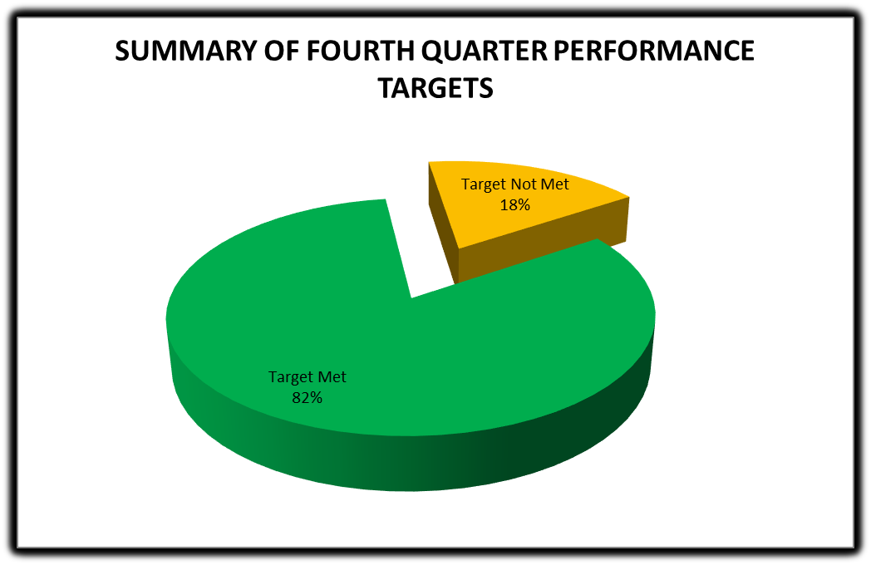

Chart 5 above provides a summary of the targets met (82%) as well the targets not met (18%). It can be stated that the performance of the municipality year ending 30 June 2019 is slightly above average. There is an excess of reasons why some of the targets could not be met, and as such, the Performance Management unit has listed all the possible challenges that have hindered to non- performance or non -implementation of the 18% targets not met.

**Departmental performance targets**

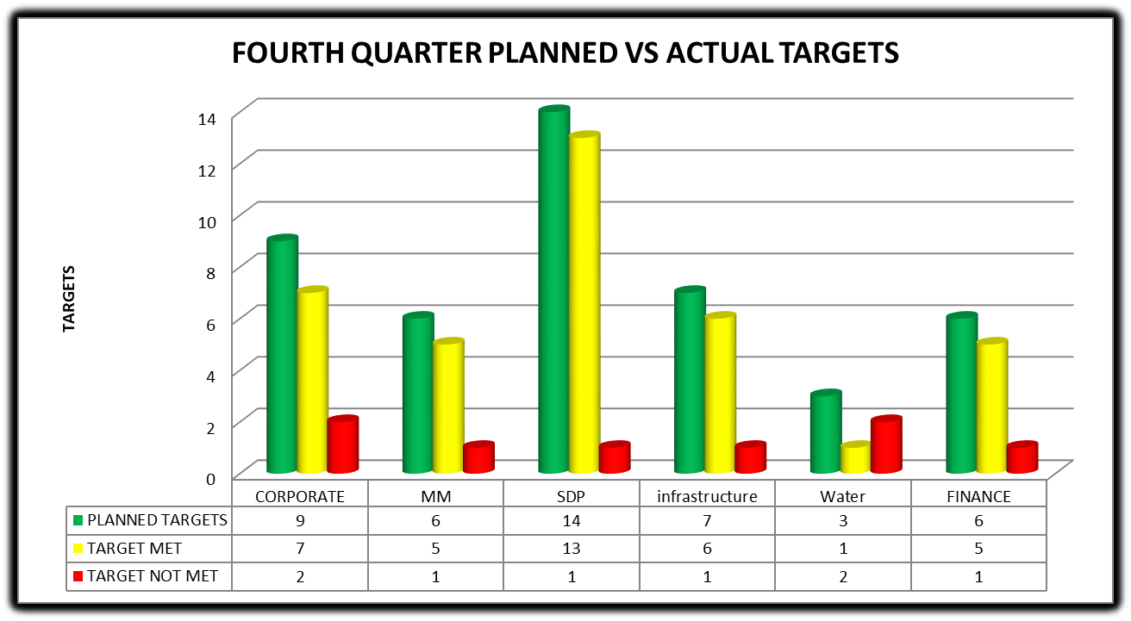

The chart below analyses the extent to which performance targets, in percentage terms, were met by ranking departments from the highest (achieved) to the lowest

**Performance Targets Departments**

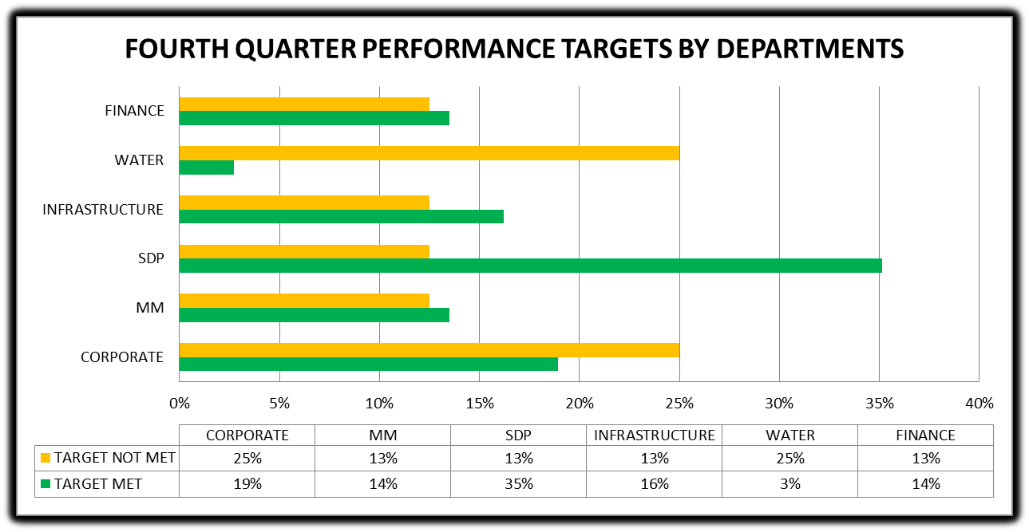

**The next section looks at the performance of the capital expenditure**



This next section looks at the performance of the capital expenditure programme. This performance is best illustrated in the charts that follow.

Chart C1 below display a comparison between the previous year’s capital expenditure performances to that of the current year for the period under review. A comparison between the monthly expenditure for the periods July to June 2019 and the planned monthly targets is also displayed

**Capital Expenditure Monthly Trend: Actual v Target**

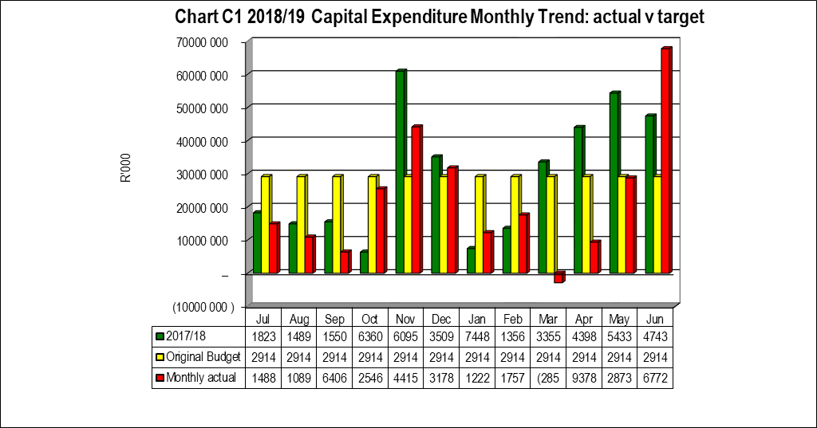

The chart below, on the other hand, track the capital expenditure’s cumulative balances budget versus actual. It is clearly that expenditure started on a rather slower trend but showed acceleration towards the end of the mid-year.

**Capital Expenditure: YTD Actual v YTD Target**

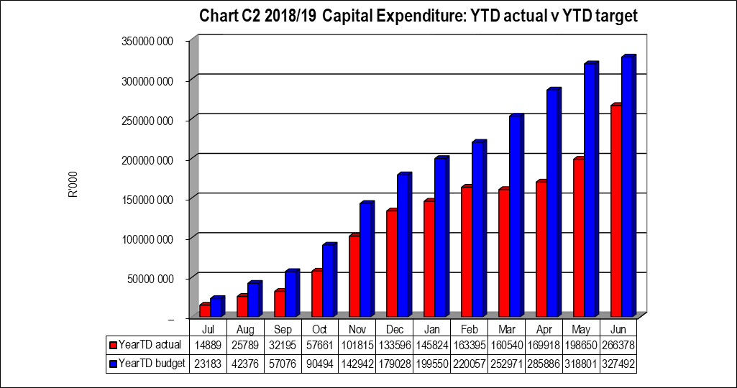

In order for the municipality to reach its annual targets in the capital development programme, expenditure in this budget would have to maintained or increased at the trends experienced in June 2019.

**Capital Expenditure on New Assets by Asset Class**



## **Municipal Manager’s Quality’s Certificate**

**Quality Certificate**

I, Adelaide Nomnandi Dlamini, the Municipal Manager of Harry Gwala District Municipality, hereby certify that-

* The monthly budget statement, and
* Quarterly report on the implementation of the budget and financial state of affairs of the municipality

For the month of June 2019 has been prepared in accordance with the Municipal Finance Management Act and regulations made under that Act.

Print name: Adelaide Nomnandi Dlamini

Municipal Manager of: Harry Gwala District Municipality

Signed____________________

Date______________________